Required Final Assignment 12.1: Types of Databases and Database Containerization
Part 1: Provide a screenshot to show that you were able to open the Final_Assignment_Module_12 folder in VS Code.
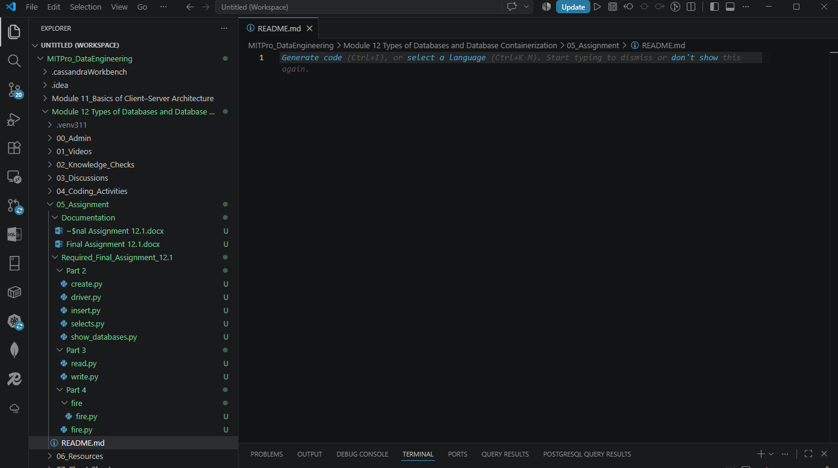
Part 2:
Provide a screenshot to show that you successfully ran the command to initialize the driver for Part 2 in VS Code.
- Provide a screenshot to show that you successfully ran the command to initialize the driver for Part 2 in VS Code.
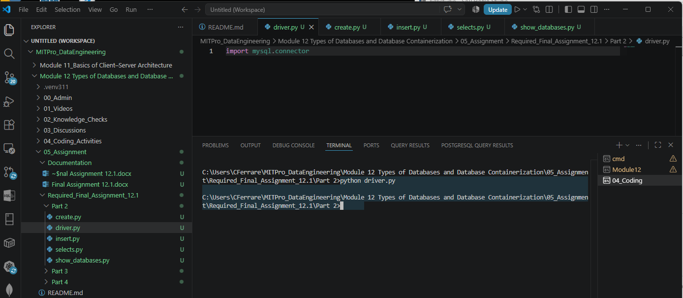
- Provide two screenshots. The first screenshot should show the code demonstrating which data you defined, including the required three entries. The second screenshot should show that you successfully ran the `create.py` file.
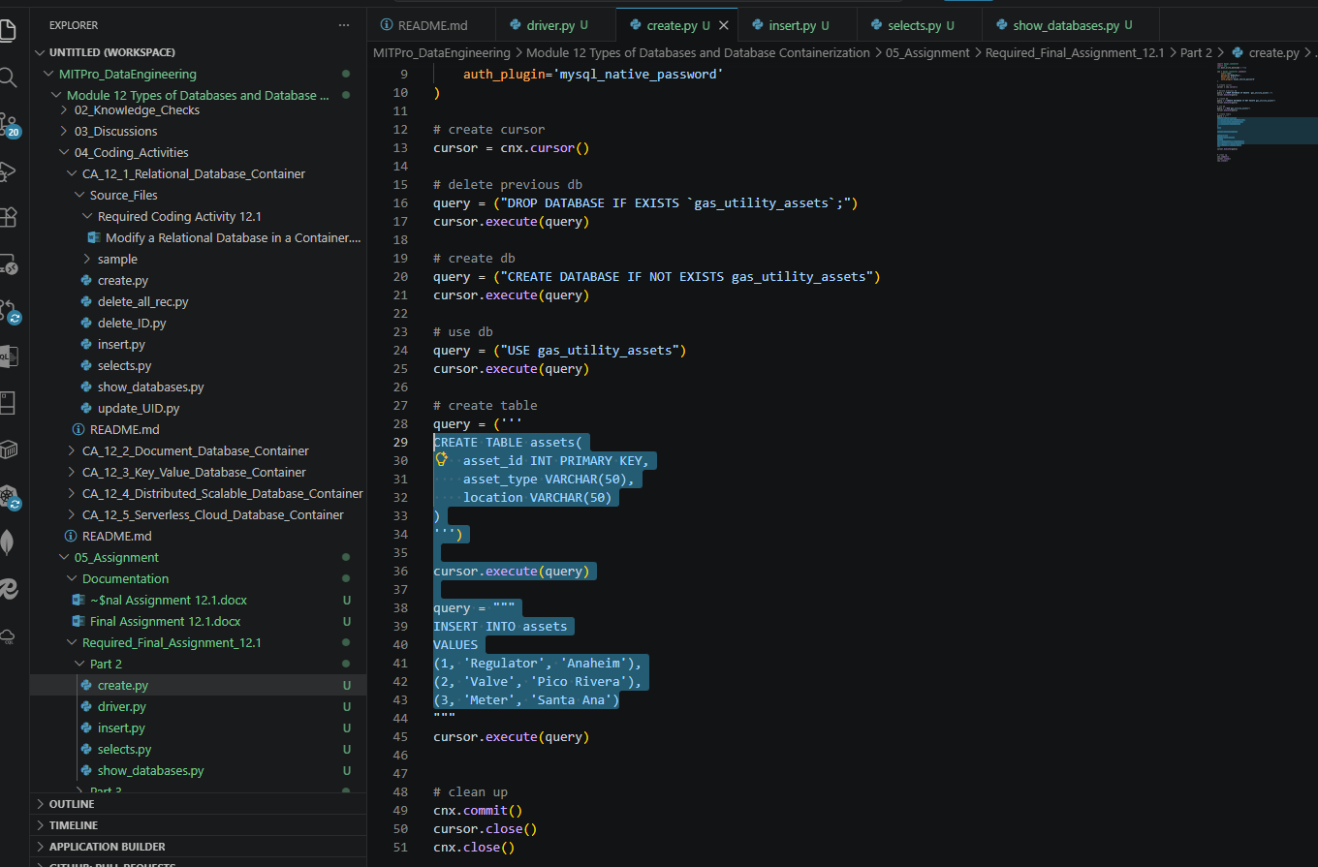

Successful run of create.py:
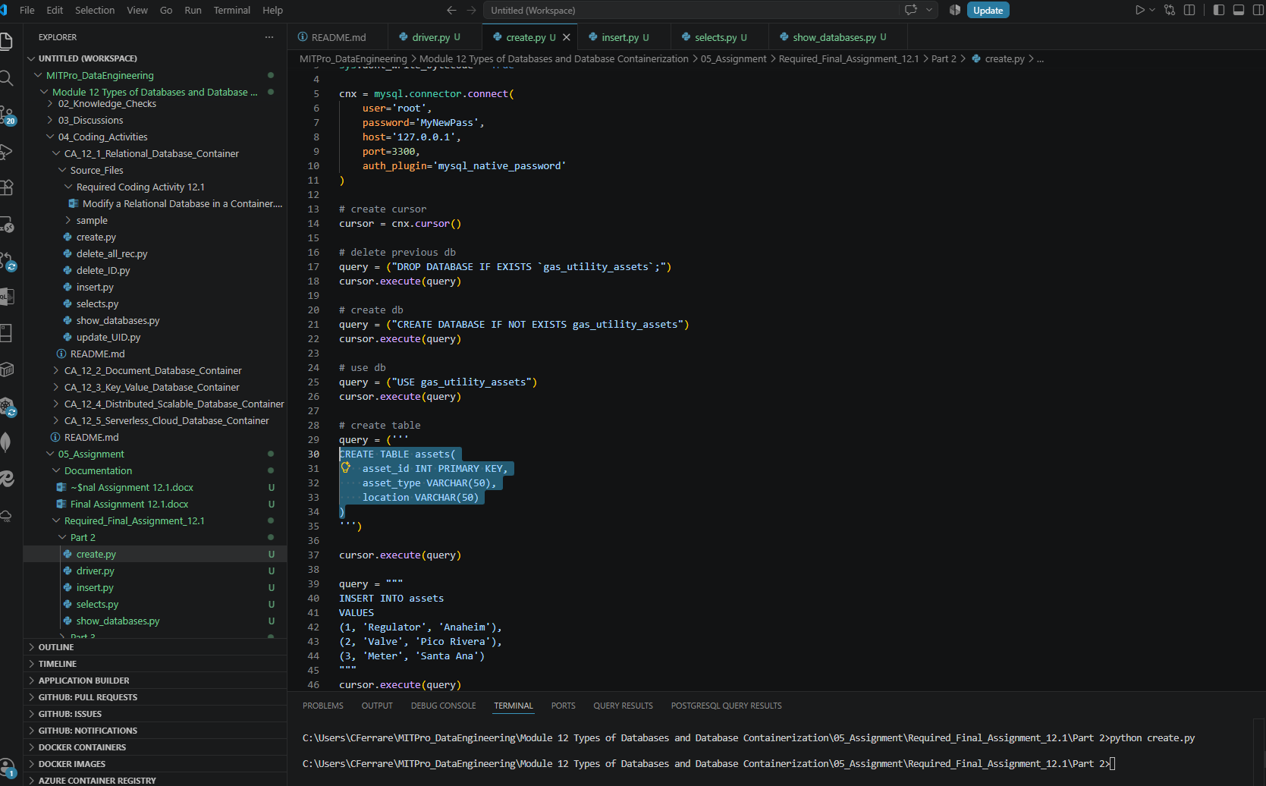
- Provide a screenshot of your Terminal window to show that your data is visualized correctly, that you ran the correct commands, and the correct entry is displayed.

Using show_databases.py:

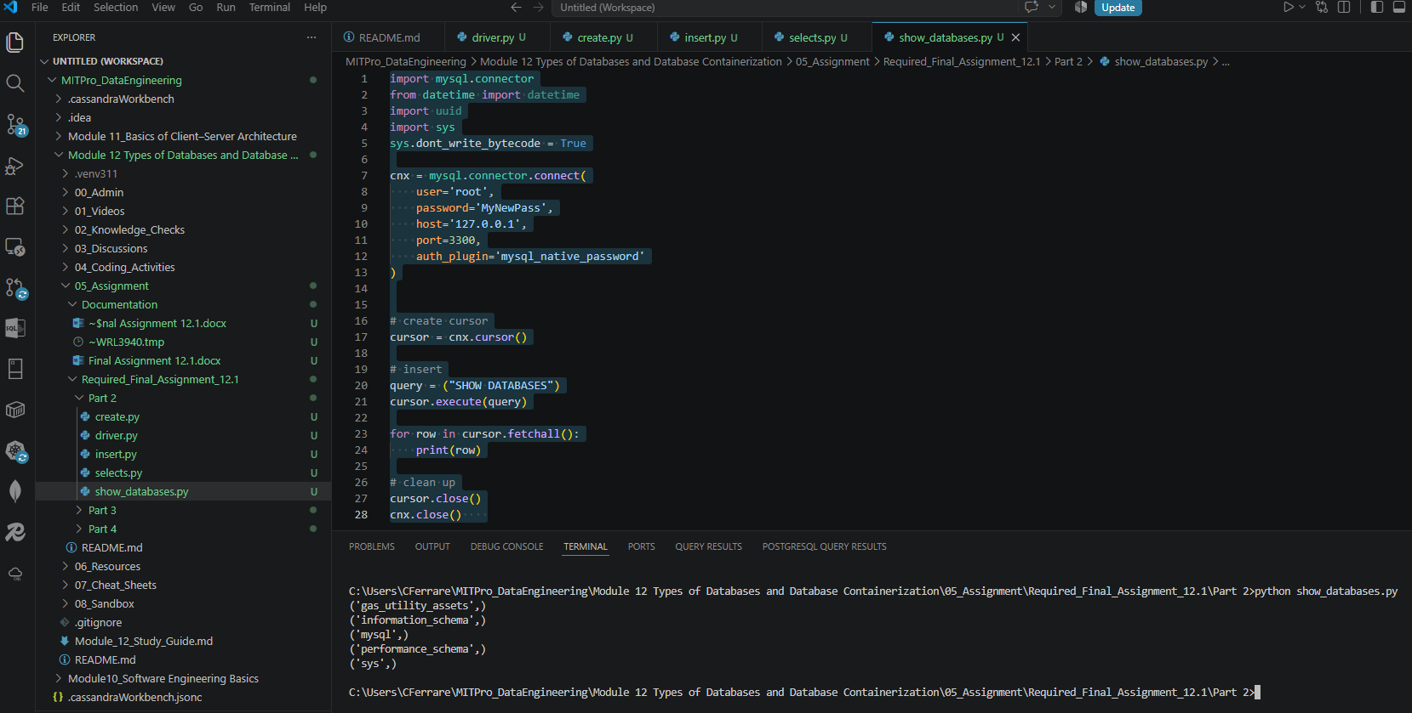

Using select.py:

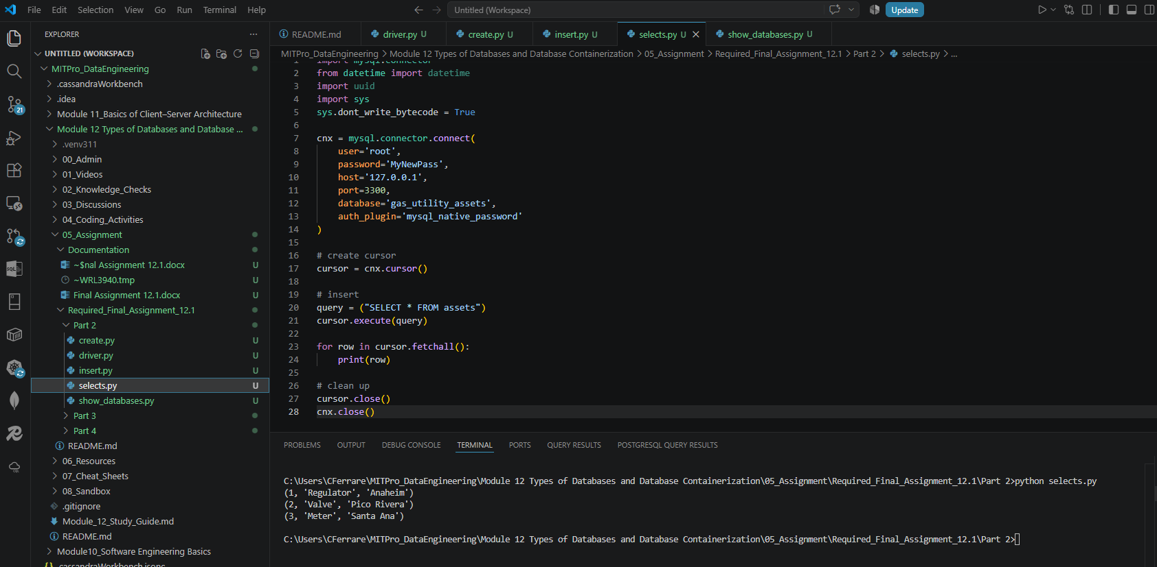

Using insert.py:

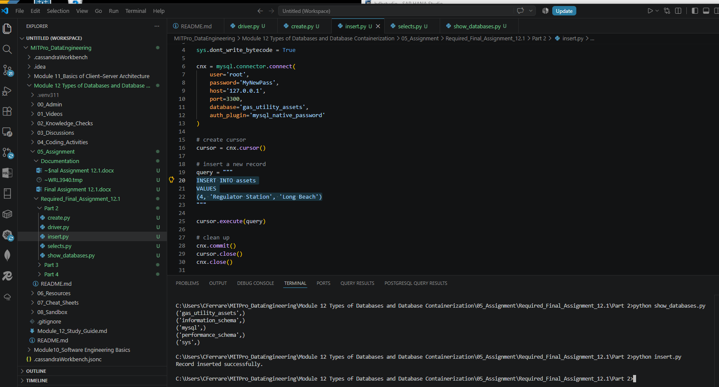

Running again the select.py to view the insert was added to our table:

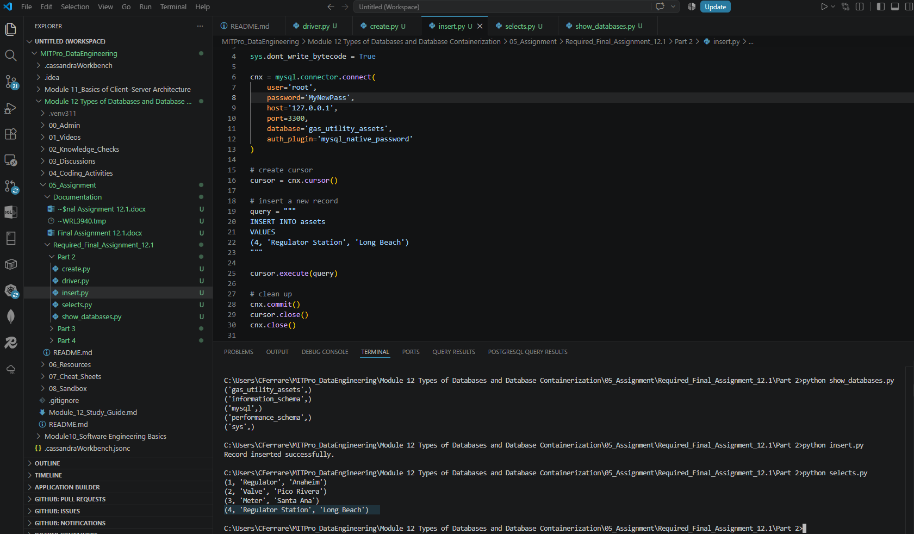

Data displayed on VSCode:

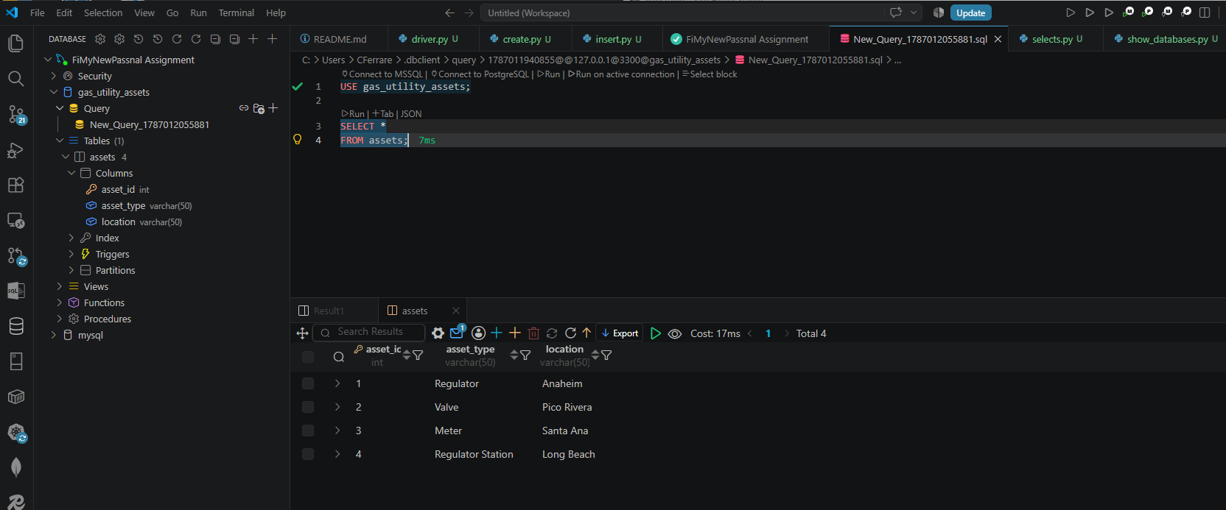

- Provide a screenshot to show that you successfully created the container named ‘final_assignment’ in Docker using port 3300.

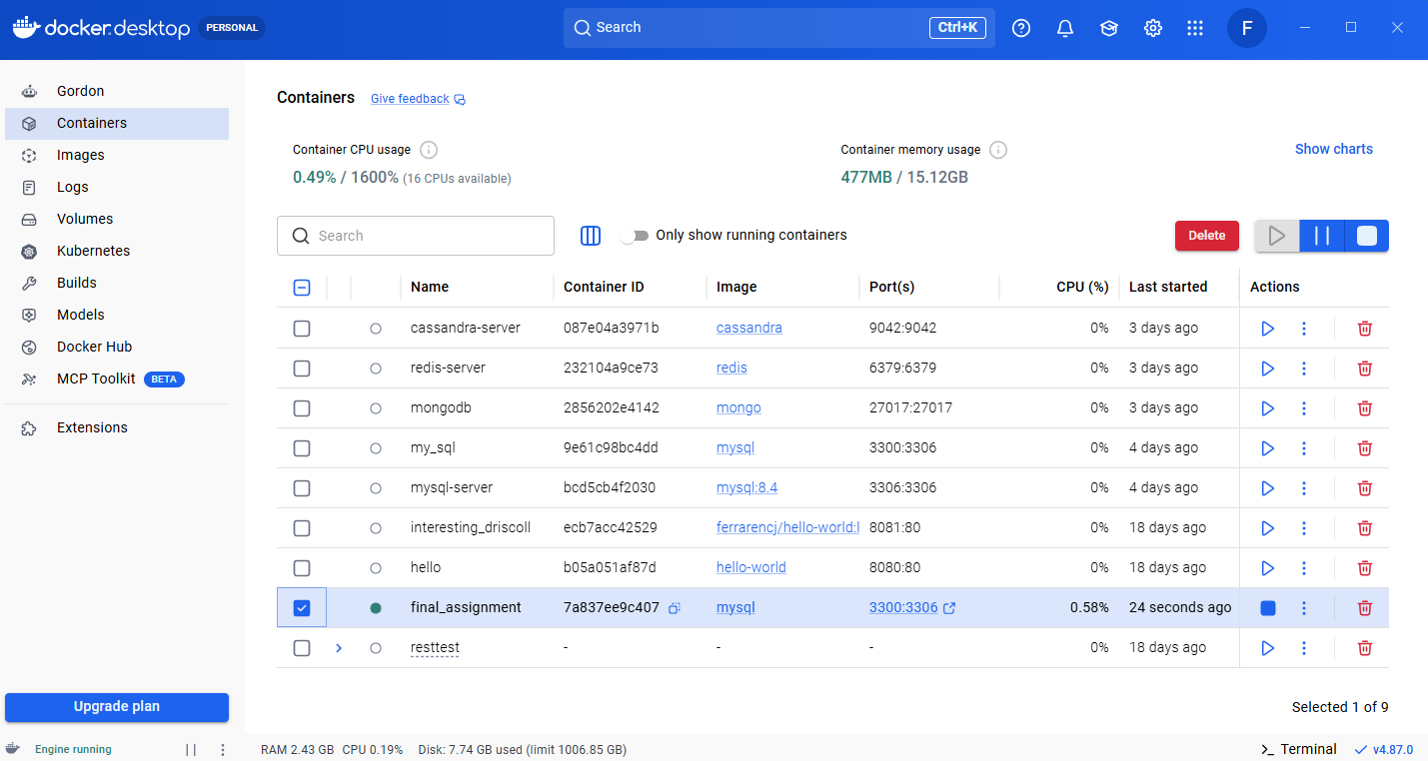

Part 2: MySQL Database Creation and Containerization
In this part of the assignment, a relational database was created using MySQL and accessed through Python. A database named gas_utility_assets was created to represent utility assets commonly used in gas utility operations. Within the database, an assets table was created with the columns asset_id, asset_type, and location.

Three records were inserted into the table:
- Regulator located in Anaheim
- Valve located in Pico Rivera
- Meter located in Santa Ana
The Python script successfully created the database, created the table structure, and inserted the records. The data was then queried using SQL to verify that all records were stored correctly.
To demonstrate database containerization, a MySQL Docker container named final_assignment was created using port 3300. Containerization provides an isolated and portable environment for running database applications, allowing the database to be deployed consistently across different systems. By using Docker, the MySQL database could be managed independently of the host operating system while remaining accessible through standard database connection tools.
The successful execution of the Python scripts, retrieval of data through SQL queries, and creation of the Docker container demonstrated key concepts of relational databases, CRUD operations, and database containerization covered in Module 12.

Part 3:
- Provide a screenshot to show that you successfully ran the command to initialize the driver for Part 3 in VS Code.
- Provide two screenshots: The first screenshot should show that you successfully ran the command to create the “final_assignment_part3” container in your Terminal window. The second screenshot should show that the container you created is active on Docker.
- Provide a screenshot to show that you successfully used the Redis method, mset, to create a dictionary, r, with keys equal to “Milk” and “Bread” and corresponding values equal to “Lactose” and “Gluten”.
- Provide a screenshot of your Terminal window running the write.py file to show that your syntax does not contain any errors.
- Provide a screenshot of the read.py file to show your updated code after you used the Redis method, get, to read all values in r.
- Provide a screenshot of your Terminal window to show that your code prints the dictionary values correctly in the read.py file.
Part 4:
Provide a screenshot to show that you successfully ran the command to open the starter file for Part 4.
Provide a screenshot to show that you created a new project called “Assignment-Module12” in Firebase.
Provide two screenshots: One screenshot should show that you navigated to the correct page in Firebase to obtain the private key, and one screenshot should show that you copied the private key file correctly into the serviceAccountKey.json file. Feel free to blur your private key in the screenshots.
Provide a screenshot to show that you created an empty Realtime database for your project in Firebase.
Provide a screenshot to show that you updated the databaseURL field in the fire.py file in VS Code with the URL that you copied.
Provide a screenshot to show that you updated two entries in your database in the fire.py file.
Provide a screenshot of your Terminal window to show that you ran the correct command to write to your database in Firebase.
Provide a screenshot from Firebase to show that your database has been written as expected.

